IN1006 Systems Architecture 2018/19

Tutorial 01 Answers: Introduction to Computer Systems

# Exercises

## Complete Session 1 self-check online tutorial questions (Moodle)

1. What is the definition of Systems Architecture? Why do all Computing students need to understand this topic?

*The fundamental organization of a (computer) system, embodied in its components, their relationships to each other and the environment, and the principles governing its design and evolution*

*To be able to use any computer system well, you need to have a good understanding of the fundamental capabilities of the hardware and be able to comprehend and work through the limitations (discussion topic)*

1. Explain layers of abstraction in computer systems?

*Computer systems can be decomposed into layers, the process of abstraction allows layers to hide lower level information from higher levels – in a way that allows the higher levels to be useful and consistent without being cluttered by unnecessary detail*

*i.e. You don’t want to think about electron flow when writing a games program!*

1. Draw and explain Von Neumann model with its five components and data paths.

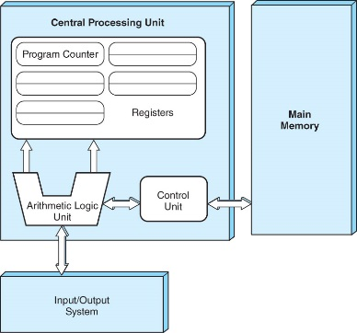

*All modern stored-program computers are based on the von Neumann model (stored program digital computer). It consists of five components:*

*1)Control Unit*

*2)Arithmetic Logic Unit (ALU)*

*3)Registers,*

*4)Main Memory System*

*5)I/O System*

*These computers have the capacity to carry out sequential instruction processing.*